**Raj Singh: COSC 4353 Software Design**

**Group 10 - Assignment 4**

**GROUP 10: Satya Sai Sribhashyam, Tasneem Patel, Jenish Bhadola**

**1. Provide link to GitHub repository for TAs to view the code.(5 points)**

<https://github.com/Jnbhadol/Project_Group10>

**2. Provide SQL statements to create database.(3 points)**

DROP TABLE User;

DROP TABLE Profile;

DROP TABLE Quote;

CREATE TABLE User(

id VARCHAR(255) NOT NULL PRIMARY KEY,

email VARCHAR(255) NOT NULL,

password STRING(255) NOT NULL,

first_name VARCHAR(255) NOT NULL,

);

CREATE TABLE Profile(

id VARCHAR(255) NOT NULL PRIMARY KEY,

full_name VARCHAR(255) NOT NULL,

address1 VARCHAR(255) NOT NULL,

address2 VARCHAR(255) NOT NULL,)

city VARCHAR(255) NOT NULL,

state VARCHAR(255) NOT NULL,

zipcode INT NOT NULL,

user_id VARCHAR(255) NOT NULL,

FOREIGN KEY(user_id) REFERENCE User(id)

);

CREATE TABLE Quote(

id VARCHAR(255) NOT NULL PRIMARY KEY,

date INT NOT NULL,

delivery_address VARCHAR(255)

gallons_requested VARCHAR(255)

suggest_price VARCHAR(255)

total_price VARCHAR(255)

user_id VARCHAR(255) NOT NULL,

FOREIGN KEY(user_id) REFERENCE User(id)

);

**3. Rerun the code coverage report and provide it. (2 points)**

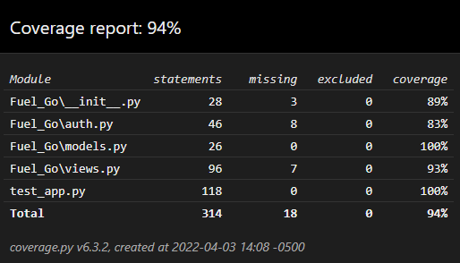

**4. IMPORTANT: list who did what within the group. TAs should be able to validate in GitHub, otherwise team members who didn't contribute will receive a ZERO.**

**Fill in this table, provide as much details possible:**

|  |  |  |
| --- | --- | --- |
| **Group Member Name** | **What is your contribution?** | **Discussion Notes** |
| **Tasneem Patel** | Database for Login/Register page, profile page, Hash password, unit testing | Database for Login/Register page, profile page, hash password inserted in the database, and helped in unit testing |
| **Satya Sai Sribhashyam** | Quote database, DB schema, display DB to history page | Database for quote page, designed DB schema, displayed info from DB to history page |
| **Jenish Bhadola** | Front end to backend, unit testing, code coverage | Ensured backend received data from frontend html pages, did unit testing and code coverage |